SUPPLEMENTARY TABLES

Supplementary Table 1. Each row shows the code used in our data, a description of the trait from its source, the units of the trait (or whether it is a binary or count), the original source of these data, percent coverage across our 277 species, and any additional notes. Continuous data from Amniote Life History Database (ALHD) represent medians of the raw data, and data from AnAge are the mean value for a species.
Trait code | Trait description | Units | Original source | Coverage (%) | Notes
ForStrat.ground | Forages on the ground (or inland waters) | binary | EltonTraits | 91.3 | Changed from percentage to a binary
ForStrat.understory | Forages below 2m in the forest | binary | EltonTraits | 89.9 | Changed from percentage to a binary
ForStrat.arboreal | Forages in trees | binary | EltonTraits | 90.6 | Changed from percentage to a binary
ForStrat.aerial | Forages above vegetation or structures | binary | EltonTraits | 91.3 | Changed from percentage to a binary
ForStrat.marine | Forages in open oceanic bodies | binary | EltonTraits | 91.3 | Changed from percentage to a binary
Activity.Nocturnal | Active during the night | binary | EltonTraits | 64.3
Activity.Crepuscular | Active during twilight | binary | EltonTraits | 63.9
Activity.Diurnal | Active during the day | binary | EltonTraits | 63.9
femal_maturity_d | Time to maturity - females | days | ALHD | 55.2
male_maturity_d | Time to maturity - males | days | ALHD | 46.6
weaning_d | Weaning duration | days | ALHD | 37.5
development_d | Gestation/incubation time | days | ALHD | 57.4 | Created from the mean of gestation time (days) and incubation time (days)
log_litterclutch_size_n | Size of litter/clutch | count | ALHD | 68.6 | Log transformed
litters_or_clutches_per_y | Number of litters/clutches in a year | count | ALHD | 55.2
log _inter_litterbirth_interval_y | Time between litters/clutches | years | ALHD | 34.7 | Log transformed
log_birthhatching_weight_g | Weight at birth/hatching | g | ALHD | 51.6 | Log transformed
log_weaning_weight_g | Weight at weaning | g | ALHD | 26.0 | Log transformed
log_adult_body_mass_g | Body mass of an adult | g | ALHD | 78.7 | Log transformed
infantMortalityRate_per_year | Infant mortality rate | count | AnAge | 4.3
mortalityRateDoublingTime_y | Mortality rate doubling time | years | AnAge | 4.7
metabolicRate_W | Basal metabolic rate | W | AnAge | 21.3
temperature_K | Typical body temperature | K | AnAge | 24.9
longevity_y | Mean longevity | years | ALHD | 67.5 | For records with no information, used the value for maximum longevity in years
log_female_body_mass_g | Body mass of a female | g | ALHD | 27.1 | Log transformed
log_male_body_mass_g | Body mass of a male | g | ALHD | 34.7 | Log transformed
adult_svl_cm | Snout vent length of adults | cm | ALHD | 55.2
diet_breadth | Percentage of diet categories | count | EltonTraits, FishBase | 82.3
tnc_ecoregion_breadth | Percentage of ecoregions covered by a species | count | This study | 89.2
mass_specific_production | Mass specific production |  | This study | 46.9 | Calculated from a formula by Hamilton et al. 2010
log_range_size | Range size | km² | This study | 89.5 | Log transformed
AA_83_y | Residue at ACE2 position 83 is a Y (Tyrosine) | binary | This study | 99.6
AA_30_negative | Residue at ACE2 position 30 is negatively charged | binary | This study | 100
log_WOS_hits_synonyms | Number of publications queried by a Web of Science topic (title and abstract) search for a species, including synonyms based on GBIF backbone | count | This study | 100 | Log transformed

Supplementary table 2. Each row shows the code used in our data, a description of the trait from its source, the units of the trait (or whether it is a binary, count, or has multiple categories), the original source of these data, percent coverage across our 126 mammal species with ACE2 sequences, and any additional notes. As in Supporting Table 1, continuous data from Amniote Life History Database (ALHD) represent medians of the raw data, and data from AnAge are the mean value for a species. See PanTHERIA metadata for how central tendencies were calculated for each variable. Binary variables of taxnomic order are not included here but were also calculated with 100% coverage.
Trait code | Trait description | Units | Original source | Coverage (%) | Notes
ForStrat_terrestrial | Forages in terrestrial habitats | binary | EltonTraits | 96.0 | Binary transformation of the sum of ForStrat categories ground, aerial, scansorial, and arboreal
ForStrat_aquatic | Forages in aquatic habitats (freshwater or marine) | binary | EltonTraits | 96.0 | Binary transformation of the sum of ForStrat categories ground (for aquatic mammals) and marine
Activity.Nocturnal | Active during the night | binary | EltonTraits | 96.0
Activity.Crepuscular | Active during twilight | binary | EltonTraits | 96.0
Activity.Diurnal | Active during the day | binary | EltonTraits | 96.0
femal_maturity_d | Time to maturity - females | days | ALHD | 81.8
male_maturity_d | Time to maturity - males | days | ALHD | 67.5
weaning_d | Weaning duration | days | ALHD | 83.3
development_d | Gestation/incubation time | days | ALHD | 84.1 | Created from the mean of gestation time (days) and incubation time (days)
log_litterclutch_size_n | Size of litter/clutch | count | ALHD | 93.7 | Log transformed
litters_or_clutches_per_y | Number of litters/clutches in a year | count | ALHD | 81.8
log _inter_litterbirth_interval_y | Time between litters/clutches | years | ALHD | 71.4 | Log transformed
log_birthhatching_weight_g | Weight at birth/hatching | g | ALHD | 84.1 | Log transformed
log_weaning_weight_g | Weight at weaning | g | ALHD | 57.9 | Log transformed
log_adult_body_mass_g | Body mass of an adult | g | ALHD | 96.8 | Log transformed
infantMortalityRate_per_year | Infant mortality rate | count | AnAge | 7.1
mortalityRateDoublingTime_y | Mortality rate doubling time | years | AnAge | 7.9
metabolicRate_W | Basal metabolic rate | W | AnAge | 38.9
temperature_K | Typical body temperature | K | AnAge | 51.6
longevity_y | Mean longevity | years | ALHD | 90.5 | For records with no information, used the value for maximum longevity in years
log_female_body_mass_g | Body mass of a female | g | ALHD | 17.5 | Log transformed
log_male_body_mass_g | Body mass of a male | g | ALHD | 41.3 | Log transformed
adult_svl_cm | Snout vent length of adults | cm | ALHD | 87.3
diet_breadth | Percentage of diet categories | count | EltonTraits, FishBase | 96.0
tnc_ecoregion_breadth | Percentage of ecoregions covered by a species | count | This study | 88.1
mass_specific_production | Mass specific production |  | This study | 77.8 | Calculated from a formula by Hamilton et al. 2010
log_range_size | Range size | km² | This study | 88.1 | Log transformed
AA_83_y | Residue at ACE2 position 83 is a Y (Tyrosine) | binary | This study | 100
AA_30_negative | Residue at ACE2 position 30 is negatively charged | binary | This study | 100
log_WOS_hits_synonyms | Number of publications queried by a Web of Science topic (title and abstract) search for a species, including synonyms based on GBIF backbone | count | This study | 100 | Log transformed
X2.1_AgeatEyeOpening_d | Age at first eye opening | days | PanTHERIA | 31.0
X9.1_GestationLen_d | Gestation length | days | PanTHERIA | 77.8
X10.2_SocialGrpSize | Social group size | count | PanTHERIA | 34.9
X24.1_TeatNumber | Number of teats present | count | PanTHERIA | 23.8
X6.2_TrophicLevel | Trophic level determined based on any dietary information | categorical (1, 2, 3) | PanTHERIA | 76.2
X13.3_WeaningHeadBodyLen_mm | Head and body length at weaning | mm | PanTHERIA | 4
X26.2_GR_MaxLat_dd | Maximum latitude of range | decimal degrees | PanTHERIA | 74.6
X26.3_GR_MinLat_dd | Minimum latitude of range | decimal degrees | PanTHERIA | 74.6
X26.4_GR_MidRangeLat_dd | Median latitude of range | decimal degrees | PanTHERIA | 74.6
X26.5_GR_MaxLong_dd | Maximum longitude of range | decimal degrees | PanTHERIA | 74.6
X26.6_GR_MinLong_dd | Minimum longitude of range | decimal degrees | PanTHERIA | 74.6
X26.7_GR_MidRangeLong_dd | Median longitude of range | decimal degrees | PanTHERIA | 74.6
X27.4_HuPopDen_Change | Mean rate of increase of human population density within the species range | count | PanTHERIA | 74.6
X28.1_Precip_Mean_mm | Mean monthly precipitation within the species range | mm | PanTHERIA | 74.6
X28.2_Temp_Mean_01degC | Mean monthly temperature within the species range | Celsius | PanTHERIA | 74.6
X30.1_AET_Mean_mm | Mean monthly actual evapotranspiration rate within the species range | mm | PanTHERIA | 74.6
X30.2_PET_Mean_mm | Mean monthly potential evapotranspiration rate within the species range | mm | PanTHERIA | 74.6
log_DispersalAge_d | Age at which young leave parent or social group | days | PanTHERIA | 16.7 | Log transformed
log_HomeRange_km2 | Size of home range of individuals or groups | km² | PanTHERIA | 50.0 | Log transformed
log_HomeRange_Indiv_km2 | Size of home range of individuals | km² | PanTHERIA | 39.7 | Log transformed
log_PopulationDensity_n.km2 | Number of individuals within 1 km² | individuals/km² | PanTHERIA | 55.6 | Log transformed
log_PopulationGrpSize | Number of individuals within a group | count | PanTHERIA | 26.2 | Log transformed
log_HuPopDen_Min_n.km2 | Minimum human population density within the species range | individuals/km² | PanTHERIA | 30.2 | Log transformed
log_HuPopDen_Mean_n.km2 | Mean human population density within the species range | individuals/km² | PanTHERIA | 74.6 | Log transformed
log_HuPopDen_5p_n.km2 | 5th percentile of human population density within the species range | individuals/km² | PanTHERIA | 50.0 | Log transformed
log_NeonateHeadBodyLen_mm | Length from nose to base of the tail of recently birthed infants or near term embryos | mm | PanTHERIA | 15.1 | Log transformed

Supplementary Table 3. The various models (continuous binding strength and the classification of zoonotic capacity or AA30 charge) run for our two datasets (297 vertebrates and 126 mammals) with all associated parameters and evaluation statistics given. The column “Wild/non-wild” refers to how we dealt with domesticated species in our dataset, either by removing them or including a binary variable on the designation of the species. Parameters used in grid search included learning rate (ETA), max depth, and number of minimum observations in each node. For each bootstrap run of 10 iterations, or 50 iterations for the mammal zoonotic capacity models, we recorded the average number of trees, and the training and the test evaluation statistic (AUC or pseudo-R²). Corrected test AUC or pseudo-R² were calculated using the mean test statistic from an equal number of iterations of a null model.
Dataset | Model | Wild/non- wild | Parameters |  |  | Evaluation
 |  |  | ETA | Max depth | Min obs. in node | Trees | Training eval. | Test eval. | Null test eval. | Corrected eval.
Vertebrates | Binding strength | NA | 0.0001 | 4 | 5 | 36,268 | 0.680 | 0.372 | -0.010 | 0.362
Vertebrates | Zoonotic capacity | NA | 0.0001 | 2 | 2 | 59,610 | 0.977 | 0.855 | 0.571 | 0.784
Vertebrates | AA30 | NA | 0.0001 | 2 | 4 | 46,176 | 0.972 | 0.868 | 0.575 | 0.793
Mammals | Binding strength | Removed | 0.0001 | 4 | 3 | 26,889 | 0.754 | 0.157 | -0.048 | 0.109
Mammals | Zoonotic capacity | Removed | 0.0001 | 2 | 5 | 44,652 | 0.997 | 0.843 | 0.618 | 0.725
Mammals | Zoonotic capacity | Variable | 0.0001 | 2 | 5 | 42,093 | 0.993 | 0.789 | 0.589 | 0.699
Mammals | AA30 | Removed | 0.0001 | 2 | 2 | 29,040 | 1.000 | 0.963 | 0.607 | 0.856

SUPPLEMENTARY FIGURES
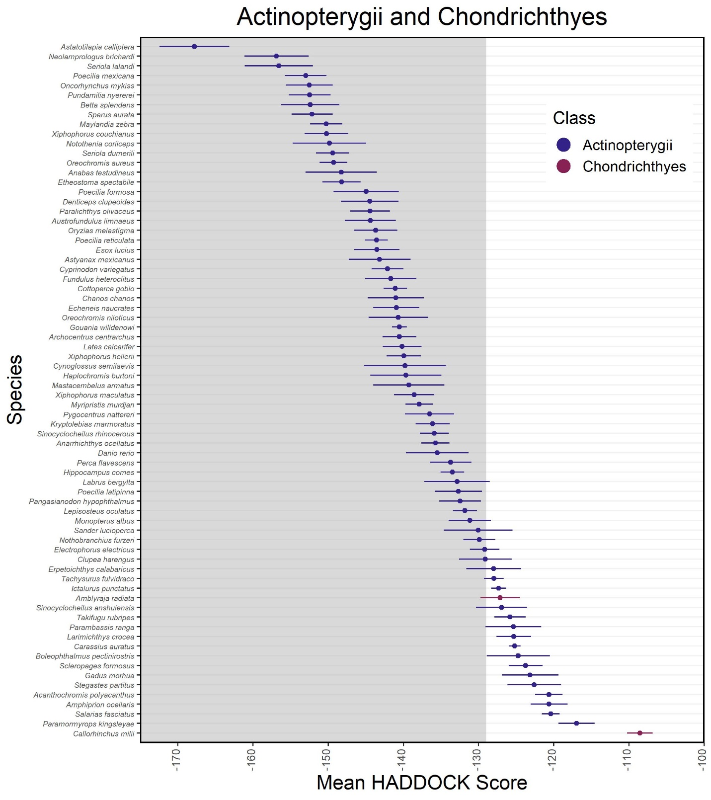
Supplementary Figure 1.. Mean HADDOCK scores (points) and their standard deviations (errorbar) for Actinopterygii and Chondrichthyes.
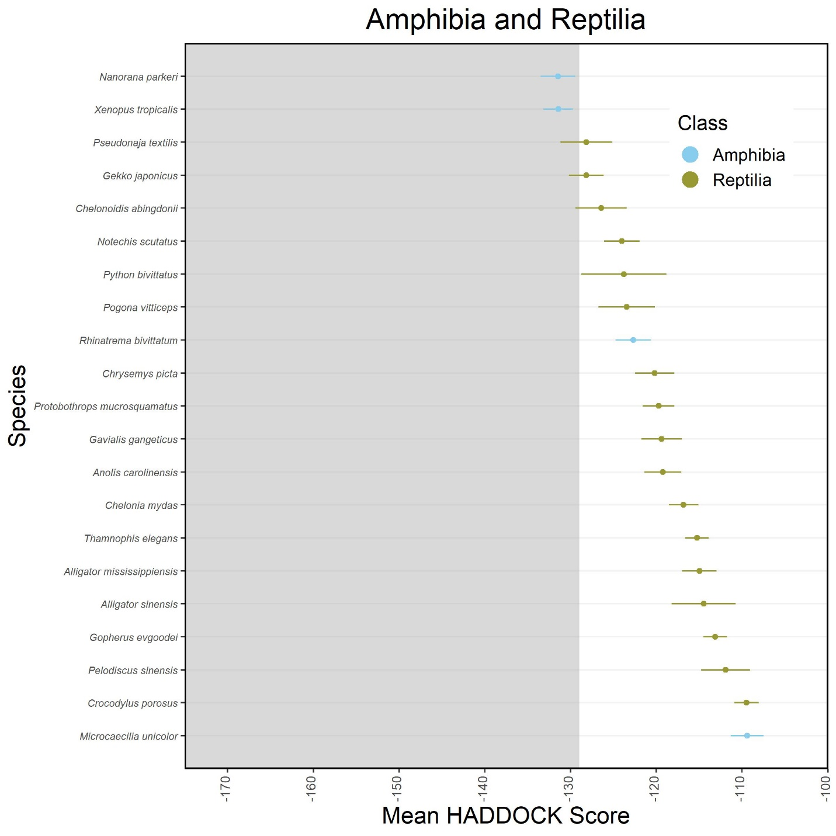
Supplementary Figure 2.. Mean HADDOCK scores (points) and their standard deviations (errorbar) for Amphibia and Reptilia.
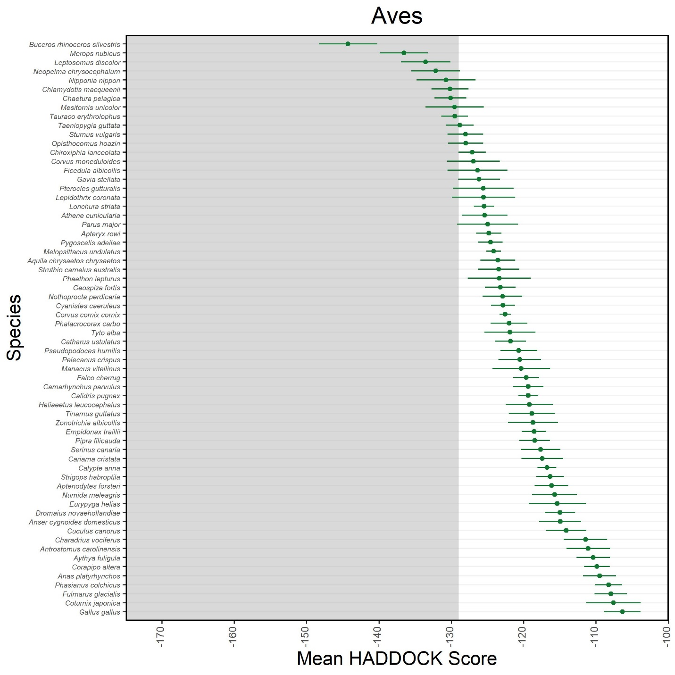
Supplementary Figure 3.. Mean HADDOCK scores (points) and their standard deviations (errorbar) for Aves.
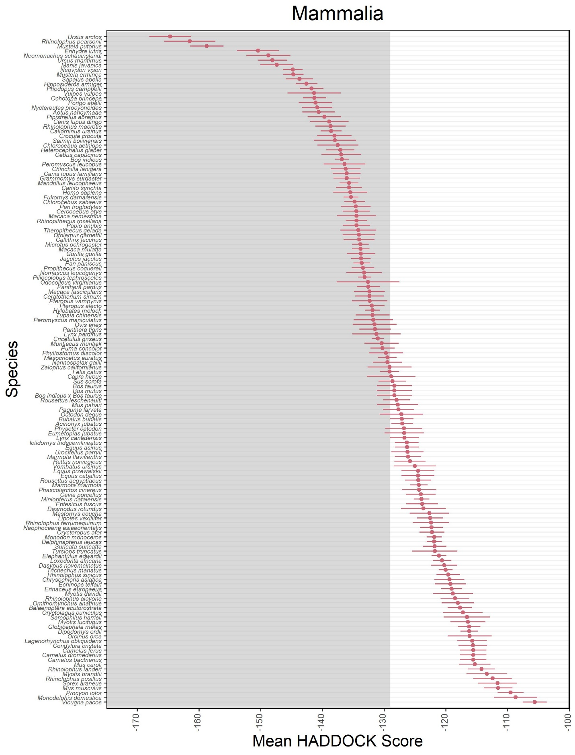
Supplementary Figure 4. Mean HADDOCK scores (points) and their standard deviations (errorbar) for Mammalia.
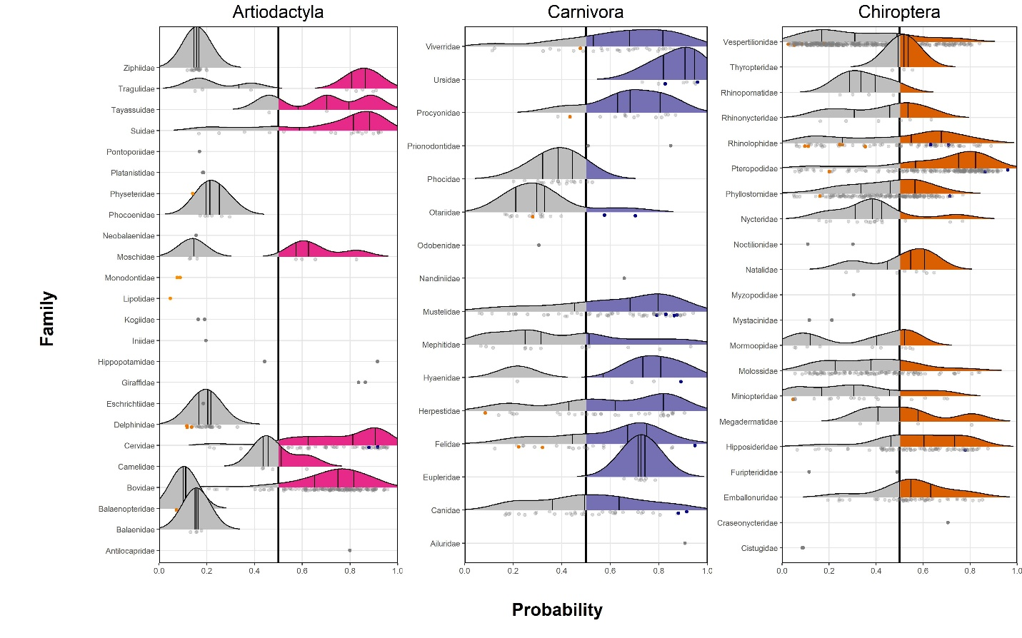
Supplementary Figure 5. Distribution of predictions by family for artiodactyls, carnivores, and chiropterans.
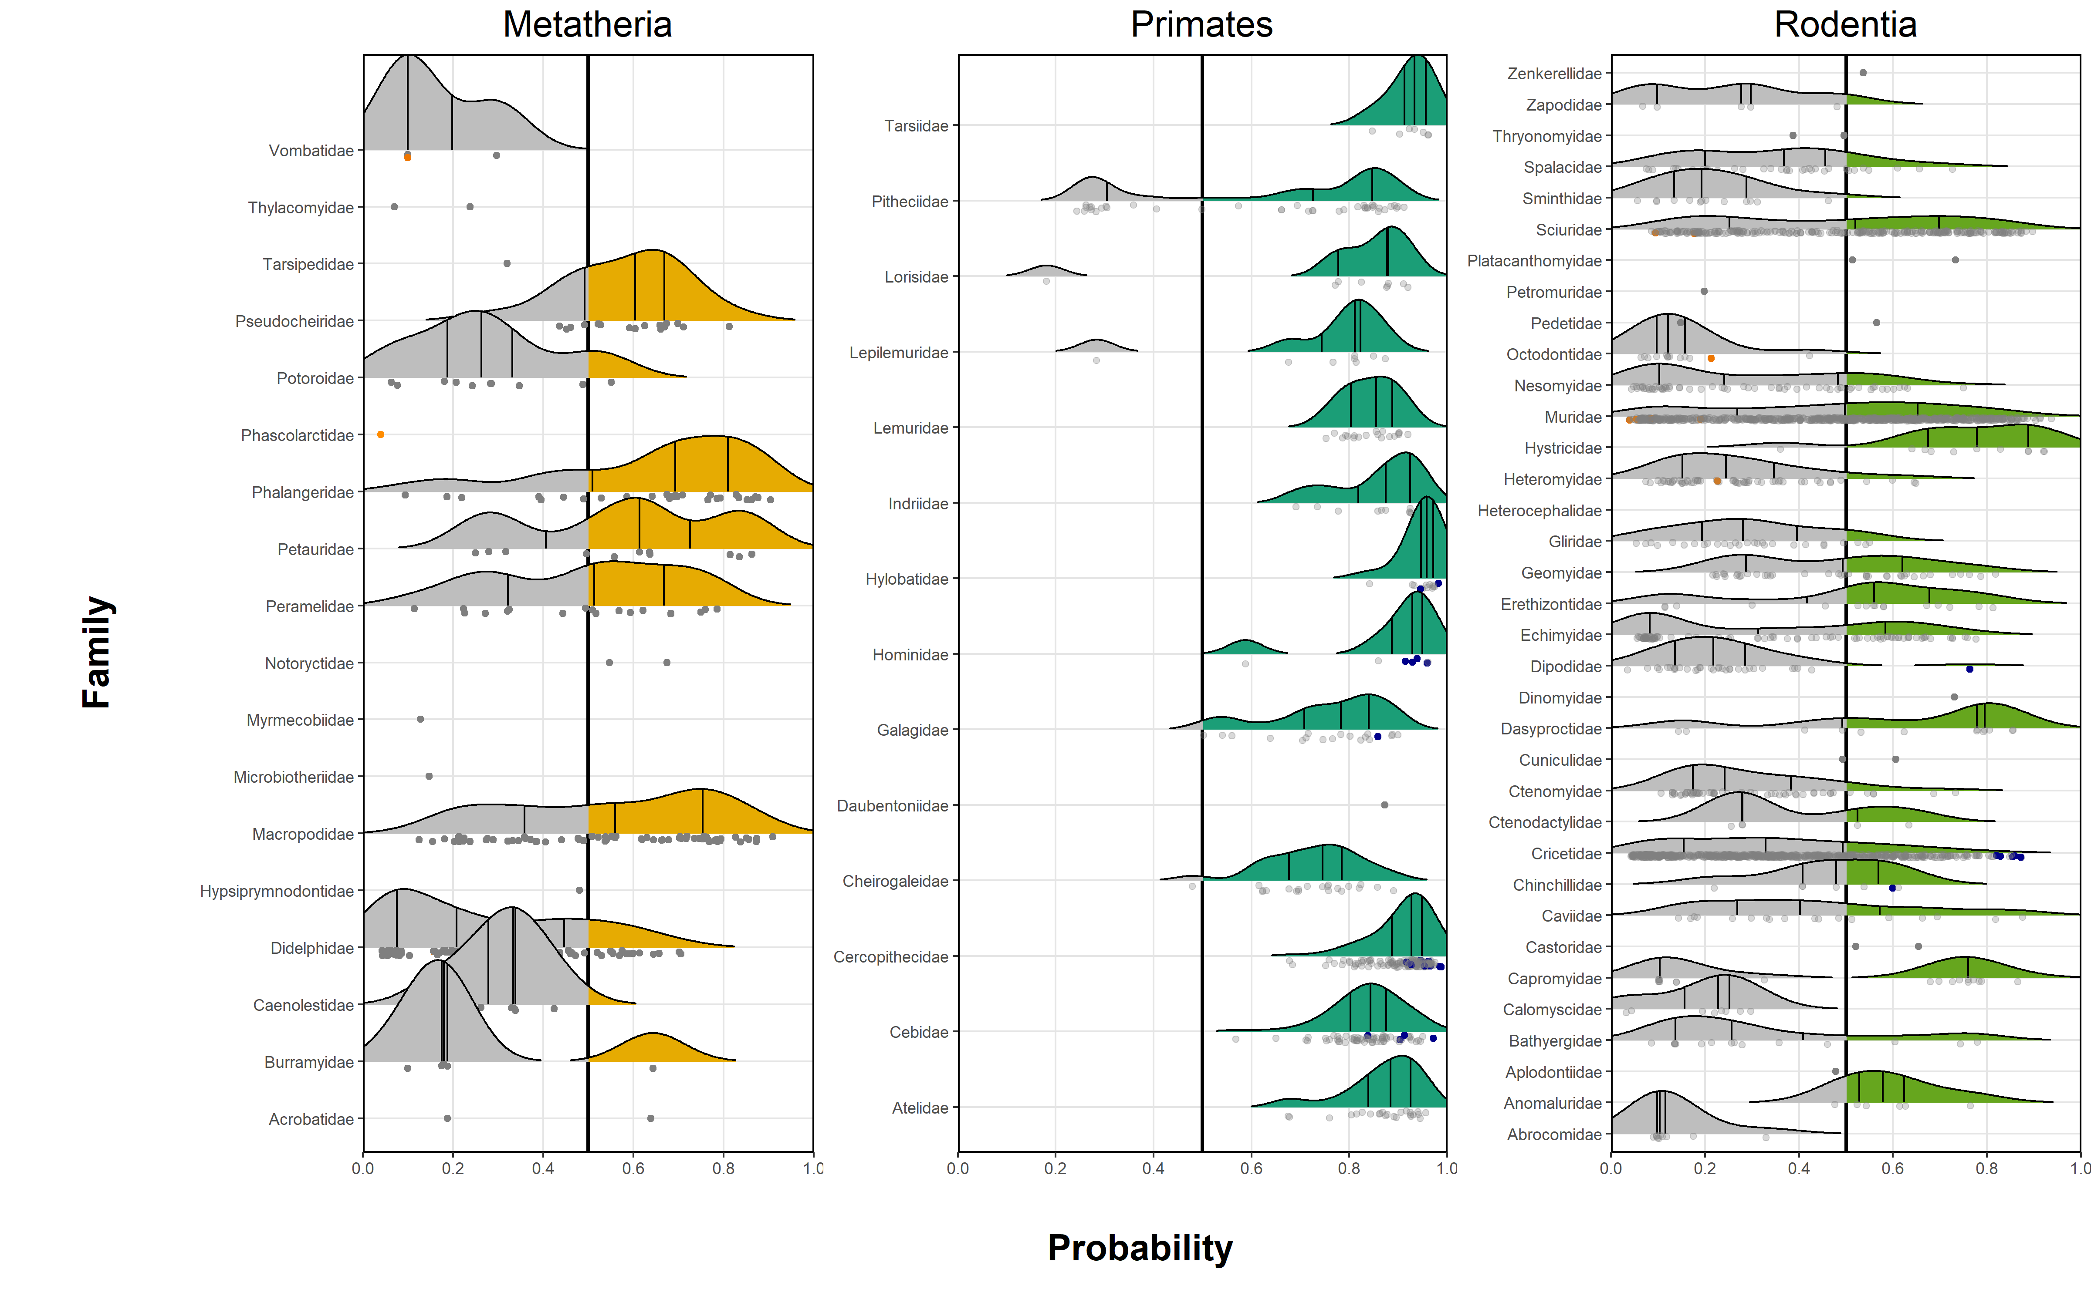
Supplementary Figure 6. Distribution of predictions by family for metatherians, primates, and rodents.
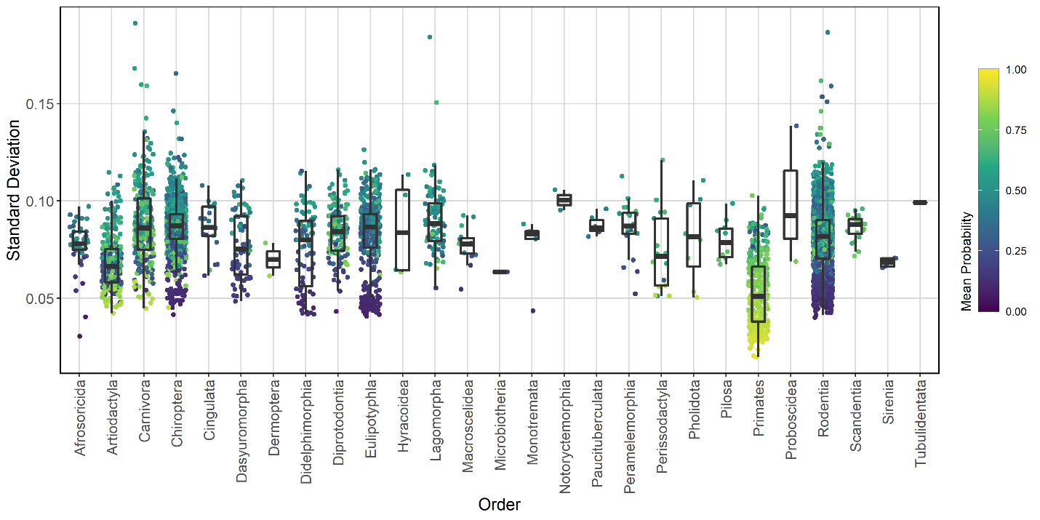
Supplementary Figure 7. Standard deviation of predicted zoonotic capacity probability for our 50 bootstrap iterations. Species are grouped by order with color representing the average zoonotic capacity probability score (warmer colors represent higher scores, indicating higher predicted zoonotic capacity, cooler represent lower scores).

